|  |  |  |  |
| --- | --- | --- | --- |
| Year 12 Worksheet 1 – Formative Assessment 3 | | | |
|  | | | |
| **Name:** | **Teacher:** | **Score /10** | |
| **Comment:** | | | **Time allowed:**  **15 minutes** |

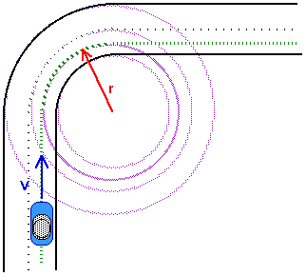

1. A car goes around the bend shown to the right.
   1. On the diagram, label the direction of its *change in velocity.* ***(2 Marks)***
   2. Support your answer using an appropriate vector method / proof. **(2 Marks)**

Δv = v – u

Δv = v + (-u) (1) or shown reversed vector as below

Δv = +

Δv (1)

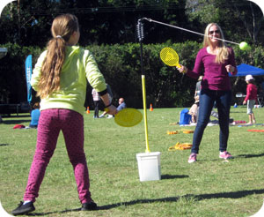

1. A mother and her daughter are playing a game of totem tennis, using a 60g tennis ball at the end of a 1.20 m string. The mother hits the ball with enough force that it moves in a circle with a 1.00 m radius from the pole.
   1. What angle does the string form with the horizontal?

**(2 Marks)**

1.20m

Cos Ɵ = 1.00/1.20

Ɵ = 33.557

Ɵ = 33.6˚ (2)

1.00m

* 1. With what speed did the ball move around the circle?

Fc

Fw = 0.060 x 9.8 = 0.588N (1)

Tan 33.6 = Fw / Fc

Fc = Fw / Tan 33.6

Fc = 0.8864 N (1)

Fc = mv2 / r

0.8864 = 0.06 v2 / 1.0

v2 = 14.77

v = 3.84 ms-1 (1)

= Fw

1. Vectors showing

Fc as component of T

**(4 Marks)**